**Thumbs Up**

Total Knockout TDD

**Nick, Angus, William, Ben, Adam, Liam and Matt**

# 

**Game Concept** **3**

**Features** **3**

**Technical Risks** **4**

**Game Flow** **4**

**GameObjects, Scripts and Systems** **5**

**Input Method** **9**

**User Interface** **9**

**System Requirements** **10**

**Third Party Tools** **11**

**Coding Conventions** **11**

**Source Control** **11**

**Team Members** **11**

# 

# 

# Game Concept

Total Knockout is a cooperative dungeon crawling game, that involves two people working together as a sweeper and a striker. The sweeper is a large character who can take out hordes of minions with a single swing, the striker can do a lot of damage to a smaller area and is more suited for taking out big bads.

They must work together to navigate through the levels, find treasure, and try not to die.

# Features

In the game, both the sweeper and the striker have:

* The ability to walk left, right, up and down
* The ability to attack using their own inventory
* The ability to use their own special move
* The ability to change characters
* A health bar each which decreases when either player gets attacked and increases when the striker defeats a miniboss (fully) and slightly when they defeat an enemy
* A cool down bar for each player

The level will include features such as:

* Gold that both players can pick up
* Swarming enemies for players to attack
* Areas for the players to explore
* Mini bosses and bosses to fight with their own health bars
* Pressure Plates that will be used to access new parts of an area
* An overall score that both players will contribute to

# Technical Risks

Programming the combat for the game will prove to be a challenge. This will be because it may be difficult to try and get the combat to feel as fluent and as satisfying as possible. We will have to work with the designers in order to achieve maximum enjoyment.

The AI in the game will also require a lot of time to perfect. This is because of the multiple elements an AI has to it including pathfinding, steering behaviours and decision making. Liam will primarily work on the AI whilst Matt will assist Liam when needed.

Getting the players to switch characters will also be difficult to program. The players must press Y within two seconds of each other in order to switch characters. We will work together to get this working efficiently in the game.

The idea of pressure plates also sound like it may be tough to implement. It may require a lot of time but Matt will make sure he programs the mechanic into Total Knockout with the help from Liam if needed.

# Game Flow

Flow of the of the project will consist of three main scenes the menu from where start, end, credits and options can be accessed.

The game itself where the game will be played and the pause menu can be accessed. The end scene which will roll credits and then go back to the start menu when done form there more minor scenes are done like the pause menu which will give the choice of options, resume and end. The options which can be accessed through the menu and pause screen will give sound options for the user to change at their leisure. The credits scene will roll through the names of the people who worked on the project and give them the roll they members played in the creation process. The pause scene gives the choice of options the same as the starting menu, resume which just exits the pause screen and end which takes you back to the starting menu. So to go over quickly what scenes are in the game:

* Start menu
* Game
* Pause
* Options
* Credits
* End

All outlined in more detail above.

# GameObjects, Scripts and Systems

The game will feature scripts for The Striker, The Sweeper, Enemies, Bosses, Gold Counter, Pressure Plates, UI and all of the scenes/menus in the game.

Sweeper:

The Sweeper will be player controlled and will move at a slower pace than the other player controlled character the Sweeper will carry a large axe that “sweeps” the enemies in front of them a health variable will be placed on the Sweeper of 100 and the axe will do 5 damage to all enemies the axe hits. Every time the Sweeper hits a Pusher or Shover type enemy then the Sweeper will get 1 or 2 Health back per kill. The Sweeper will have another attack that needs to recharge after use it will swing around it’s axe in a full 360 degree turn attacking all enemies hit with the same damage as a regular attack this will also give the Sweeper a fraction longer range with the axe. In addition when the other player controlled character dies the Sweeper will gain an extra 10 damage on top of its original 5.

Striker:

The Striker, like the Sweeper, is player controlled intended to dart around a level with high movement and it fights best against bosses and enemies with high health. They cannot fight smaller enemies as The Sweeper can but they can fight into tight areas that The Sweeper has no access to and can attack stronger enemies efficiently. The Striker can also drag boxes which activates pressure plates. When dragging a box, The Striker’s speed will decrease and cannot attack anyone until they let go of the box. The Striker uses a sword to “Strike” with and deals 20 damage, and has a health pool of 25. The Striker receives 2 health from killing a Shover and regains all health from defeating a mini boss. The striker can charge attack by holding down RB on the xbox controller and does 50 damage and takes 3 seconds to charge up. The charge is set only to facing in the direction The Striker is facing. When The Sweeper dies, The Striker gains an extra 15 health.

Pusher:

The pusher is a small enemy that does little or no damage and is basically just an annoyance to the players. Pushers will swarm the players and push them out of the way, this will only affect the Striker as he will be the same size as them. Health pool of 5.The pusher will also wander the map until it reaches 10 meters from the players when this happens the pusher will chase after the player characters and start to attack.

Shover:

The shover is a small enemy that uses a weapon dealing 5damage to the player. They will be found within groups of Pushers to add the threat level to as group of non damage dealing enemies. Health pool of 10. The shover will also wander the map until it reaches 10 meters from the players when this happens the shover will chase after the player characters and start to attack.

Throwers:

The Thrower is a small enemy that throws a projectile that deals 10. It has a health pool of 5.When the thrower is more than 15 meters away it will not be able to see the players at 15 meters it will follow the players if they move and will attack at 15 meters away.

Spirit (Mini Boss):

The spirit is a ranged enemy that shoots a projectile that deals 20damage on hit of a target Long range with slow movement speed. It has a health pool of 80. The spirit will be able to see the players at 15 meters away and start to attack the players when it sees them.

Mad Man (Mini Boss):

The Mad Man is a large enemy who has a Fastmove speed and slow attacks dealing 15damage per swing. The Mad Man has a health pool of 100. The Mad man will move to attack the players when it reaches 15 meters away from them until then it will wander the level without purpose.

Boss:

Large enemy that waits in The final area for the Players to show up. They will have 200 hp and deal 25 Damage per Attack. It will move slower and rely on the smaller enemies to slow down the players to catch up and deal a devastating blow.

Gold Counter:

The Gold Counter script will keep track all gold that has been collected from dead enemies. This will be your total score at the end of the game and will determine how well the players did.

Camera:

The camera will be looking down on both of the players and will stay in the middle of both the striker and the sweeper. This will be managed by collecting the exact middle position of the players which will become the centaur of the screen showing both players and a small area around them. This camera will not be split screen making sure to change the area shown depending on how far the players are around them.

Pressure Plates:

The script for the Pressure Plates will be rather simple. All we are checking is if a box has been placed on a switch. If there is a box on the switch, then open up a new area of the level for the players to explore.

Main Menu:

From the Main Menu, the game can be accessed as well as the options menu and the credits. The start menu will also allow players to be able to exit the game.

Options Menu:

The options menu will keep track of all the sound of the game. This includes the master volume (the music and sound effects), the music volume and the sound volume. The player can adjust each volume via this menu. The menu can be accessed from the Main Menu and from the pause screen of the game.

Pause Menu:

The script for the Pause Menu will be rather simple. All we will be checking for is if any one of the players have hit start on their controllers. If someone has hit start, the Pause menu will pop up. From their, the Game can be continued, the Options menu can be accessed and the Player can be sent back to the Main Menu from the Pause Menu.

Credits:

When the game is complete or when the Play Credits button is pressed in the Main Menu, the Credits will run. This will features some simple slow scrolling text with everyone’s name who contributed to the project and a simple background. When complete, the player will be thrown back to the Main Menu.

# Input Method

The Input Method for Total Knockout will be through the use of two controllers. These two controllers attached to the PC will control everything about your character and pause the game. The input for these controllers are:

* Left stick to move the character
* Right stick to move camera in a specific direction
* Right trigger to attack in direction character is facing
* Right bumper to use the characters special
* The A button to interact with an object
* The start button will pause the game
* The Y button to swap characters (this must be done within 2 seconds of each controller to activate a character swap)

# User Interface

The user interface will be simple and show all things that need to be seen it will show:

* A gold counter at the top middle of screen
* the player’s health bars at lower left hand side of screen
* The special abilities bar at the lower right hand side of the screen
* The top right will show the mini bosses health

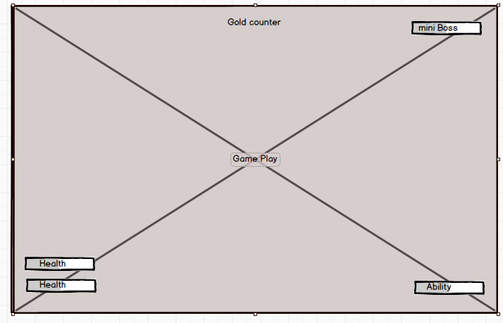

# System Requirements

The system requirements for this project are as follows:

* Operating System - Windows XP SP2 or better
* Graphics card - DX9 (shader model 3.0) or DX11 with feature level 9.3 capabilities or better
* CPU - SSE2 instruction set support or better

These match the requirements for a Unity game and these are the most basic requirements needed.

# Third Party Tools

The third party tools on this project will be:

* Unity version 2017.1.0f3
* Some assets from the unity store
* Visual Studio 2017

These third party tools will help to create this project to it best possible standard.

# Coding Conventions

The coding conventions for this product will be hungarian notation when appropriate (for private variables) and capitalisation for variables this includes camel casing when needed (for public variables). These coding conventions give the variables a neater look while still being distinctive from one another. When commenting, a space will be put after the double dash just so the comments look neater.

# Source Control

Source control for this project will be set up with SVN downloaded to all team members computers the file location will be using the github servers. The only rule to adhere to is to make sure that no two members of the team are ever working on the same thing at any same time this can cause problems for all members that may work on the same part of the project later on.

# Team Members

Matthew Le Nepveu - object, mechanics and character Programmer

Liam Knights - NPC, AI and character Programmer

Nick Barnett - Producer

Angus Phasey - Designer

William Thong - Artist

Benjamin Bragg - Artist

Adam Grincais - Artist